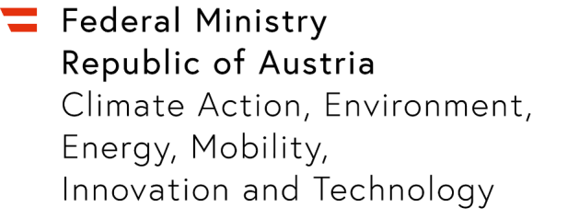

Expression of Interest for an IPCEI Photovoltaic
  - Stage 1
Please complete this template with your project sketch, do not exceed 8 pages (except cover page) (Font: Calibri, size 12 pt margins, single space line pitch).

Company and Contact
Please state the company name, address and contact details

  - Brief introduction of the company and relevant experience

  - Description of the planned project and feasibility of the IPCEI criteria
Please provide an overview of the project content and objectives and explain whether the criteria specified in the call for expression of interest can be met.
  - Goals and Reference to national and European strategies
Please describe the desired goals as well as the reference to national and European strategies such as climate and energy goals, as the “European Green Deal”, REPowerEU and if applicable the EU digital strategy as well as Fit for 55.
  - Tentative survey of investments
Please provide an estimation of the planned total investments in the RDI-, FID- and mass production phase.
  - Survey of project-related co-operations
If other companies interested in the IPCEI are already known, these are to be included here with details of the planned form of co-operation.
  - Tentative time plan

  - Market Failure
Please describe why the project could not be realised and implemented in this form without state aid under the current market conditions.
  - Reference to the IPCEI
If applicable, please give information on the pan-European IPCEI project in which the specific project is to be embedded.
  - Contact information
Please state the name of the contact person(s) with e-mail address and telephone number.

